Module 3 Assignment - Website SQL Queries
Name: Helen Zhang (hzhan308)

SQL Logic and Terminal Results:
- How many entries do you have in your database who have applied for Fall 2026?
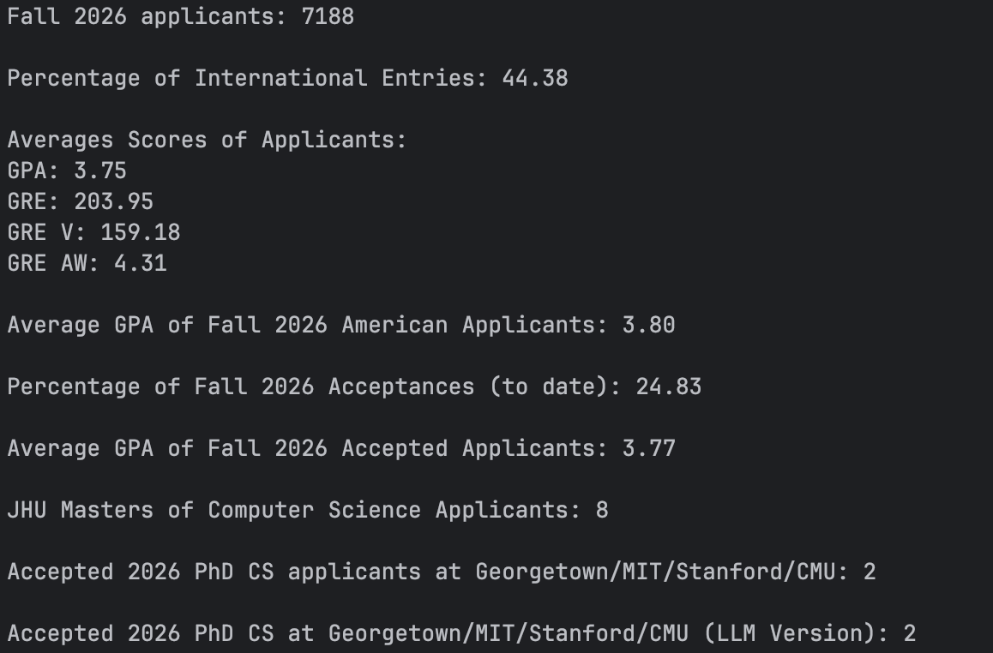
SQL Logic: Counts using Count(*) the number of rows in database using a where statement to filter the term is “Fall 2026”

- What percentage of entries are from international students (not American or Other) (to two decimal places)?
SQL Logic: Calculates the percentage of records using a where statement to filter us_or_international is “International” using case when… then 1 SQL logic. This is divided by the total number of rows and rounded (using round()) to two decimals

- What is the average GPA, GRE, GRE V, GRE AW of applicants who provide these metrics?
SQL Logic: Calculates the averages (using AVG) of the GPA and GREs. It only allows for values that are both not 0 and also within typical GPA and GRE ranges using a where statement to remove any non-possible cases. This is then rounded (using round()) to two decimals

- What is their average GPA of American students in Fall 2026?
SQL Logic: Calculates average GPA using (AVG) using a where statement to filter us_or_international is “American” and term is “Fall 2026”. It additionally restricts the GPA to realistic cases so excluding missing GPAs and any value above an A+ or 4/33.

- What percent of entries for Fall 2026 are Acceptances (to two decimal places)?
SQL Logic: Computes the percent (same as question 2) using a where statement to filter term is “Fall 2026” and status is “Accepted” using the same logic as question 2 and rounds the percentage to two decimals.

- What is the average GPA of applicants who applied for Fall 2026 who are Acceptances?
SQL Logic: Calculates the average GPA (using AVG) using a where statement to filter status is “Accepted” and term is “Fall 2026”. This also removes any missing and invalid GPAs.

- How many entries are from applicants who applied to JHU for a masters degrees in Computer Science?
SQL Logic: Counts the number of records using a where statement to filter degree to 1.0, program that matches “Computer Science, and university that matches Johns Hopkins/JHU checking both the raw and LLM fields. ILIKE ANY is used to further clean any weird text patterns in university.

- How many entries from 2026 are acceptances from applicants who applied to Georgetown University, MIT, Stanford University, or Carnegie Mellon University for a PhD in Computer Science?
SQL Logic: Counts the number of records using a where statement to filter term to Fall and Spring 2026, status to “Accepted”, degree to 2.0, program that matches “Computer Science, and university that matches the name patterns. ILIKE ANY is used to further clean any weird text patterns in program and university.

- Do you numbers for question 8 change if you use LLM Generated Fields (rather than your downloaded fields)?
SQL Logic: Same logic as question 8 but matches and filters using llm_generated_program and llm_generated_university instae of the raw program and university. ILIKE ANY is used to further clean any weird text patterns in program and university.

- For UNC Chapel Hill Fall 2026 semester, how many accepted Master’s applicants were there by program?
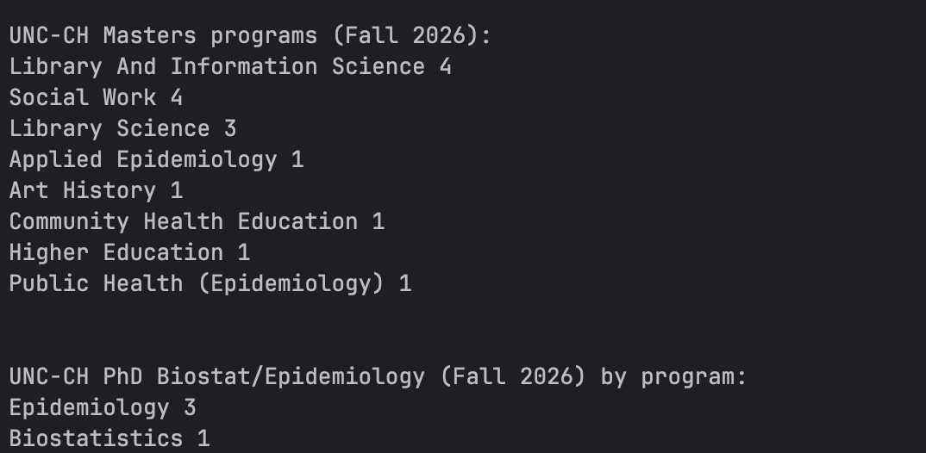
SQL Logic: Counts the number of records using a where statement to filter term to “Fall 2026”, status to “Accepted”, degree to 1.0, and university that matches the name patterns for UNC CH. Group by is used to provide a program level breakdown to see how many acceptances there have been so far by program. Coalesce is used to improve the cleaning/review of the llm_generated_program and raw program fields. The responses are sorted by number of acceptances and then in alphabetical order by program name. ILIKE ANY is used to further clean any weird text patterns in program and university.

- For UNC Chapel Hill Fall 2026 semester, how many PhD applicants in Biostatics or Epidemiology were there by program?
SQL Logic: Counts the number of records using a where statement to filter term to “Fall 2026”, degree to 2.0, and university that matches the name patterns for UNC CH. Group by is used to provide a program level breakdown to see how many acceptances there have been so far by program. Coalesce is used to improve the cleaning/review of the llm_generated_program and raw program fields. The responses are sorted by number of acceptances and then in alphabetical order by program name. ILIKE ANY is used to further clean any weird text patterns in program and university.

Website Screenshots:
